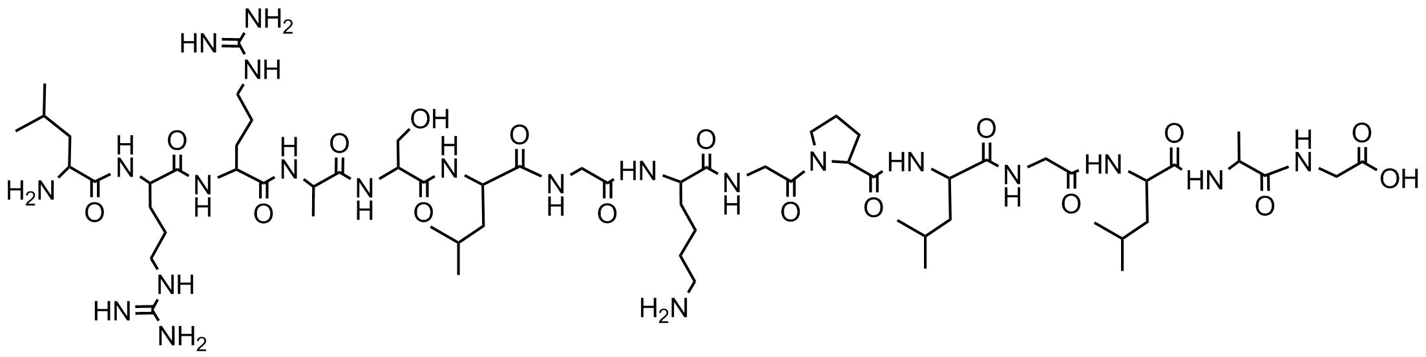Problem 1:

Problem 2:

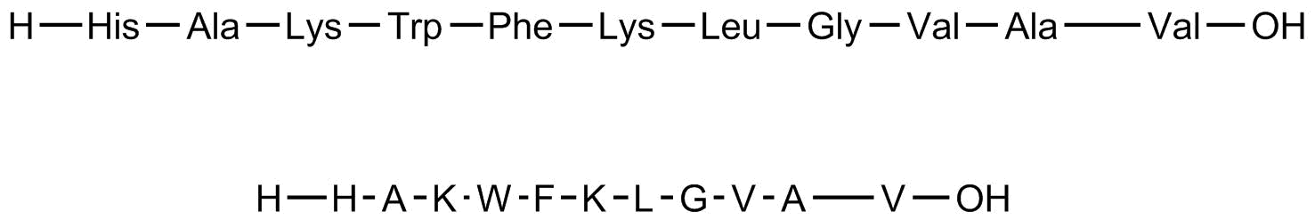

This could be synthesized using a resin functionalized with amine groups. Then, each amino acid could be added in order, going from right to left in the sequence above. Before reacting, the amino acids need to be deprotected so that they are able to react. In addition to this, amino acids like lysine and tryptophan also have to be protected in the R groups because they could also react to form a peptide bond.

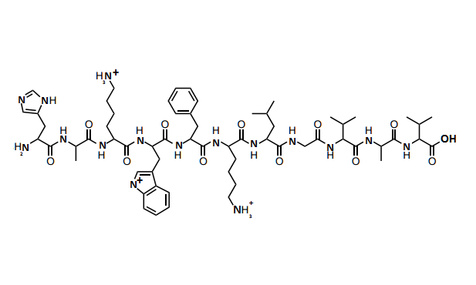

Problem 4:

The paper “Hydrogels for biomedical applications” by Allan S. Hoffman discusses the basics of hydrogel synthesis and composition as well as some of their physical properties. Then, it relates these properties to possible biomedical applications like drug carriers and tissue engineering matrices. Hydrogels are hydrophilic polymer networks that absorb water. The amount of water absorbed my very from 10-20% to thousands of times their dry weights. These networks could be physical (reversible), which could be broken down by changes in pH, like calcium alginate, or by changes in temperature and other environmental changes, or chemical (permanent) like hydroxyl methacrylate (HEMA) with the crosslinker ethylene glycol dimethacrylate EGDMA. Some methods of creating physical hydrogels include cooling or warming a polymer solution, crosslinking a polymer in an aqueous solution, lowering pH or mixing solutions of polyanions and polycations. Sole methods of making chemical hydrogels include crosslinking using radiation, chemical crosslinkers, or multifunctional reactive compounds, copolymerizing a polymer and monomer in solution, or chemically converting a hydrophobic polymer into a hydrogel.

Chemical hydrogels are not homogeneous; they often contain regions with high cross link density called ‘clusters’, leading to less water uptake and less swelling, and regions with low cross link density. Sometimes, ‘voids’ or ‘macropores,’ water-filled gaps in the network, may form. Some of the possible macromolecular structures for hydrogels include cross-linked networks of linear homopolymers, linear copolymers, block or graft copolymers, polyion–multivalent ion, polyion–polyion or H-bonded complexes, hydrophilic networks stabilized by hydrophobic domains, and interpenetrating polymer networks (IPNs) or physical blends. In addition to this, hydrogels can be synthesized using naturally forming polymers, like collagen and shark cartilage, artificial polymers, or even a combination of the two.

Initally, water is absorbed to the most hydrophilic sites, followed by the hydrophobic sites. This initial absorption is known as the “total bound water.” Then, more water is absorbed through osmosis to swell the hydrogel. This is called “free water” or “bulk water.” Eventually, the hydrogel reaches an equilibrium swelling level. Due to the quick interchange of water molecules between the bound state and the free state, it is difficult to estimate the relative amounts of total bound water and free water in a hydrogel. The main three methods for doing so are small molecular probes, DSC, and NMR. The probe can only be absorbed by the free water, so the amount of free water can be found from the difference between the absorbed concentration of the probe and the initial concentration of the probe. In DSC, it is assumed that only the free water freezes, so the spike in the graph indicates the melting of the free water. In both cases, once the amount of free water is found, the amount of bound water can be found by subtracting from the total absorbed water.

Another important property of hydrogels is the presence of pores. The amount and shape of the pores are generally described using “tortuosity.” Once again, molecular probes can be used to measure tortuosity. Pores are especially important when considering the usage of a hydrogel as a drug release mechanism. How quickly the hydrogel would release a certain drug would be affected by the pore shape and size, how many pores there are in the hydrogel, the size of the drug used, and how the drug interacts with both the solvent the hydrogel is in and with the polymer network of the hydrogel. The pore shape, size, and the number of pores are all affected by the crosslink density and composition of the polymer network, so it is very important to take these factors into account when choosing a hydrogel for this application. In addition to this, hydrogels are very viable as a method for tissue regeneration. Hydrogels can act as scaffolds that allow living cells to grow in their pores, or they may be designed to degrade over time, releasing growth factors that promote cell growth. They can also be injected as liquid and then made into a gel at body temperature. However, most hydrogels have weak mechanical properties, which makes it difficult to handle them when implanting them into the body. While there are still problems to be faced, hydrogels have great potential to be useful in this field.

Problem 5.1: One example is poly(2-hydroxyethyl methacrylate – co – acrylic acid) (poly HEMA –co-AA). It cross links chemically when combined with a crosslinker to form the structure below.

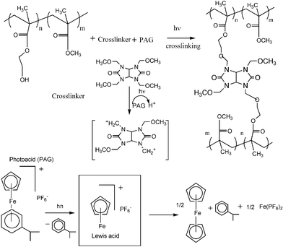

The dependence of hydrogel properties on pH once again makes this hydrogel useful to use with a human body. Because blood glucose levels can change blood pH, these hydrogels might be used to provide insulin when the blood pH is too low.

Problem 5.2: One example is the copolymerization of multiarm PEG-based macromers with different functionalities. Here, a PEG macromer functionalized with an aryl thiol (red) binds with a PEG macromer functionalized with a maleimide (blue). The resulting hydrogel is chemically crosslinked.

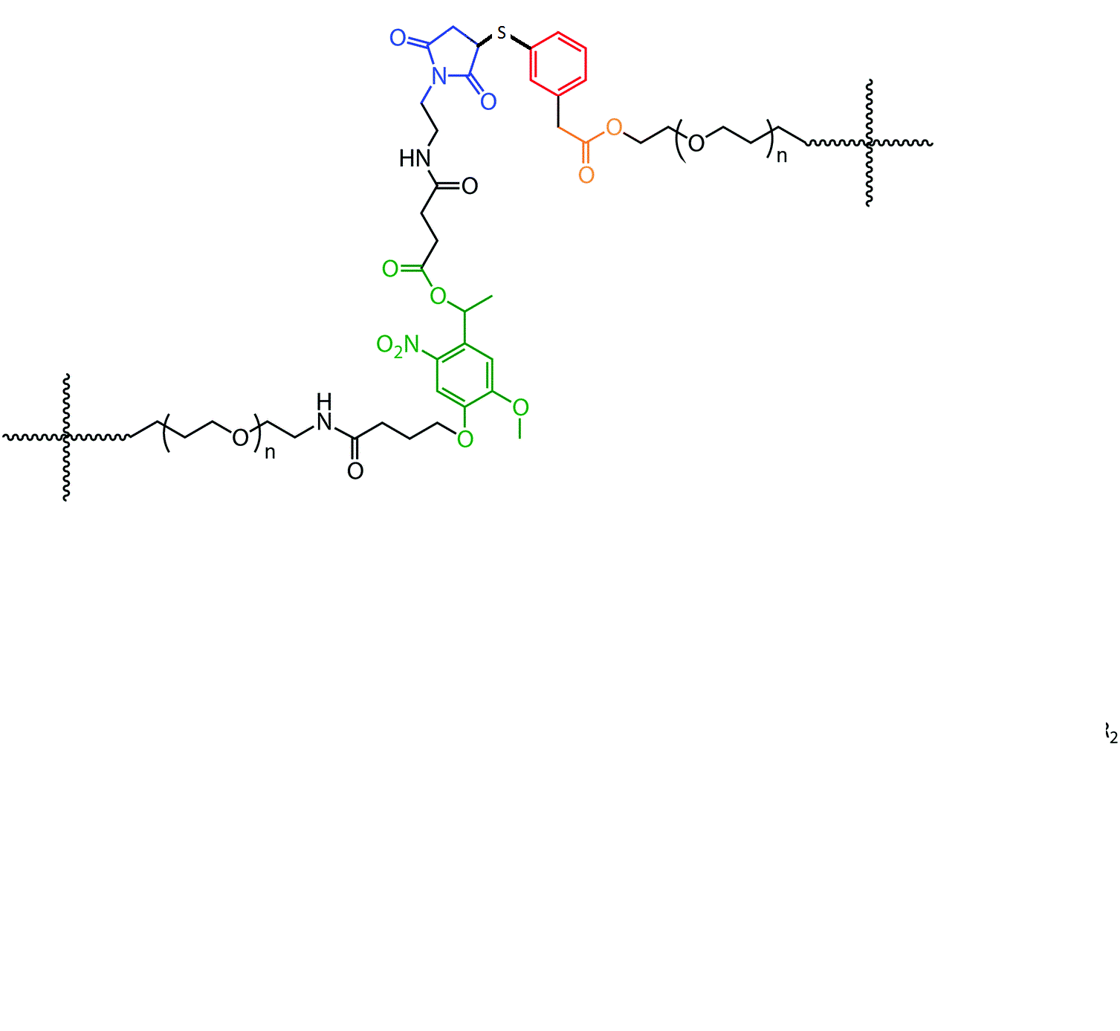

Light-sensitive hydrogels are mainly useful because they can be triggered by an external stimuli, allowing fine control of their material properties. Some applications include drug-delivery and enzyme control.

Problem 5.3: One example is poly(N-isopropylacrylamide) (NIPAA). It links chemically when combined with N,N’-methylene-bis-acrylamide (MBAm) to form the structure below

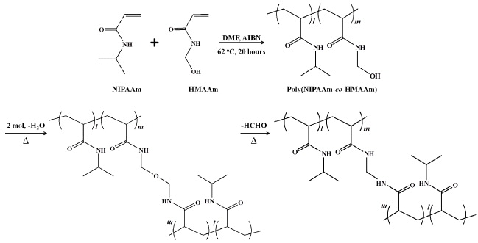

This hydrogel is useful because it has a phase transition above 30 C, causing it to release much of its contained water. This makes it perfect for drug delivery since drugs could be loaded initially and then released once the hydrogel is injected into the body.